SIMATS ENGINEERING (SAVEETHA SCHOOL OF ENGINEERING)
Department of Computer Science and Engineering
CO1 ASSESSMENT TOOL 2 – Agile Sprint Planning & User Story Workshop

Course Code: | CSA10 / CSA1063 | Course Title: | Software Engineering
CO Assessed: | CO1 | Assessment: | Assessment Tool 2 – Agile Sprint Planning & User Story Workshop
Weightage: | 20% | Total Marks: | 25
CO1 Statement: | Apply advanced methodologies and agile project management techniques to manage software projects effectively
Student Name: | Tejashwini S | Reg. No.: | 1925260043
Date: | 08.10.26 | Duration: | 60 minutes

Code of Conduct
I TEJASHWINI S 1925260043 (Name / Reg No) certify that this submission is my original work and that I have adhered to the guidelines specified for this assessment. I understand that any violation of academic integrity rules will result in disciplinary action.
Signature of the Student: _________________________

Annexure A – Agile Sprint Planning & User Story Workshop

AI-BASED INTELLIGENT FOOD PACKAGING MATERIAL RECOMMENDATION SYSTEM FOR FOOD COMMODITIES

Agile Sprint Planning & User Story Workshop

1. Project Vision and Stakeholders

Project Vision
The vision of the project is to develop an AI-based intelligent recommendation system that recommends the most suitable packaging material for different food commodities based on factors such as food type, moisture content, shelf-life requirements, temperature, storage conditions, and packaging
requirements.

Objectives
- Recommend suitable packaging materials for different food commodities.
- Reduce food spoilage caused by unsuitable packaging.
- Improve food shelf life and quality.
- Help users make faster and better packaging decisions.
- Provide an easy-to-use web-based recommendation system.
- Use AI/ML techniques to generate suitable packaging recommendations

Key stakeholders
- Food Producers and Manufacturers – Use the system to select suitable packaging materials for different food commodities.
- Packaging Manufacturers – Use recommendations to identify appropriate packaging materials for food products.
- Food Quality and Safety Experts – Ensure that recommended packaging materials meet food safety and quality requirements.
- System Administrator – Manages users, packaging data, and system configuration.
- Consumers – Benefit from improved food preservation, quality, and shelf life.
- Development Team – Designs, develops, tests, and maintains the AI-based system

2.Create Epics and User Stories

Epic 1: Food Commodity Input

User Story 1:
As a food producer, I want to enter the details of a food commodity, so that the system can identify suitable packaging materials.

User Story 2:
As a user, I want to provide food characteristics such as moisture level and storage condition, so that I can receive an accurate recommendation.

Epic 2: AI-Based Recommendation

User Story 3:
As a food producer, I want the system to recommend suitable packaging materials, so that I can select the best packaging option for my food product.

User Story 4:
As a user, I want to understand why a packaging material is recommended, so that I can make an informed decision.

Epic 3: Packaging Material Information

User Story 5:
As a user, I want to view the properties of recommended packaging materials, so that I can understand their suitability.

User Story 6:
As a user, I want to compare different packaging materials, so that I can choose the most appropriate option.

Epic 4: Recommendation Results

User Story 7:
As a user, I want to view the recommended packaging material with a suitability score, so that I can easily identify the best option.

User Story 8:
As a user, I want to receive alternative packaging recommendations, so that I have multiple suitable choices.

3.Create Epics and User Stories

Epic 1: Food Commodity Input

User Story 1:
As a food producer, I want to enter the details of a food commodity, so that the system can identify suitable packaging materials.

User Story 2:
As a user, I want to provide food characteristics such as moisture level and storage condition, so that I can receive an accurate recommendation.

Epic 2: AI-Based Recommendation

User Story 3:
As a food producer, I want the system to recommend suitable packaging materials, so that I can select the best packaging option for my food product.

User Story 4:
As a user, I want to understand why a packaging material is recommended, so that I can make an informed decision.

Epic 3: Packaging Material Information

User Story 5:
As a user, I want to view the properties of recommended packaging materials, so that I can understand their suitability.

User Story 6:
As a user, I want to compare different packaging materials, so that I can choose the most appropriate option.

Epic 4: Recommendation Results

User Story 7:
As a user, I want to view the recommended packaging material with a suitability score, so that I can easily identify the best option.

User Story 8:
As a user, I want to receive alternative packaging recommendations, so that I have multiple suitable choices.

4.Prioritize the Product Backlog

Must Have

- Enter Food Commodity Details
- The system should allow users to enter important details about the food commodity.
- AI-Based Packaging Recommendation
- The system should recommend suitable packaging materials using AI.
- Display Recommendation Results
- The system should clearly display the recommended packaging material.
- Suitability Score
- The system should provide a suitability score or ranking for the recommended packaging material.

Should Have

- Packaging Material Information
- The system should provide information about the properties and benefits of recommended materials.
- Alternative Recommendations
- The system should provide additional suitable packaging options.

Could Have

- Packaging Material Comparison
- The system could allow users to compare different packaging materials.
- Recommendation History
- The system could store previous recommendations for future reference.

Won't Have

- Online Packaging Ordering
- Online purchasing or ordering of packaging materials is outside the scope of the initial system.

5. Plan the Sprint Backlog

Sprint 1 Goal

Develop the basic version of the AI-based food packaging recommendation system.

Sprint 1 User Stories

User Story 1: Enter Food Details
As a user, I want to enter details about a food commodity so that the system can understand its packaging requirements.

User Story 2: Process Food Data
As a system, I want to process the entered food details so that the AI model can identify suitable packaging materials.

User Story 3: Recommend Packaging Material
As a user, I want the system to recommend suitable packaging materials so that I can select an appropriate option for my food product.

User Story 4: Display Recommendation Score
As a user, I want to see a suitability score for each recommended packaging material so that I can identify the most suitable option.

Sprint Tasks

Task 1: Create the food commodity input page.

Task 2: Add fields such as food type, moisture level, storage condition, and required shelf life.

Task 3: Prepare the food and packaging material dataset.

Task 4: Clean and preprocess the dataset.

Task 5: Train the AI/ML model using the prepared dataset.

Task 6: Test the AI model with sample food commodities.

Task 7: Connect the trained model to the web application.

Task 8: Display the recommended packaging material.

Task 9: Display the suitability score and alternative recommendations.

Task 10: Test the complete system and fix errors.

Sprint 1 Deliverable

A working web-based prototype that accepts food commodity details and provides suitable packaging material recommendations with a suitability score.

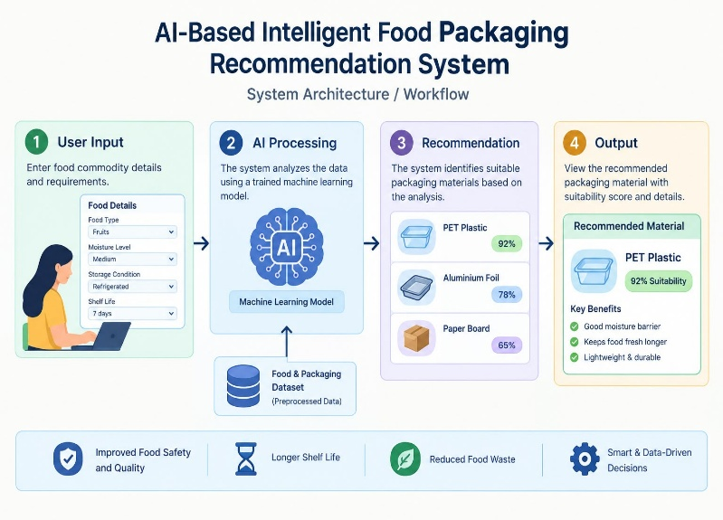
6. Estimate Effort Using Story Points

Estimation Method

The Fibonacci sequence (1, 2, 3, 5, 8, 13) is used to estimate the effort required for each user story.

User Story 1: Enter Food Details

Story Points: 3

The task involves creating a simple input form and adding fields for food type, moisture level, storage condition, and shelf-life requirements.

User Story 2: Process Food Data

Story Points: 5

The task involves cleaning, preprocessing, and preparing the food and packaging data for the AI model.

User Story 3: Recommend Packaging Material

Story Points: 8

This requires preparing the dataset, training the AI/ML model, testing it, and integrating it with the system.

User Story 4: Display Recommendation Score

Story Points: 5

The system needs to calculate, process, and display the suitability score for the recommended packaging material.

Total Estimated Effort

3 + 5 + 8 + 5 = 21 Story Points

Sprint 1 Estimated Effort: 21 Story Points

7. Sprint Goal and Expected Deliverables

Sprint Goal

To develop a basic AI-based web system that accepts food commodity details and recommends suitable packaging materials based on the given requirements.

Expected Deliverables

- Food Commodity Input Interface – A simple webpage for entering food details.
- Food and Packaging Dataset – A dataset containing food characteristics and suitable packaging materials.
- Pre-processed Dataset – Clean and organized data prepared for AI/ML processing.
- AI/ML Recommendation Model – A trained model that predicts suitable packaging materials.
- Recommendation Module – A module that generates packaging recommendations based on user inputs.
- Suitability Score – A score or ranking showing how suitable each packaging material is.
- Web Interface – A user-friendly interface for entering details and viewing recommendations.
- Testing Report – Results of testing the system to ensure that the recommendation process works correctly.

Rubrics for Calculation
Criteria | Excellent (5 Marks) | Good (3 Marks) | Satisfactory (2 Marks) | Needs Improvement (1 Mark)
Project Vision & Stakeholder Identification (30%) | Project vision is clear, comprehensive, and aligned with the problem statement. All relevant stakeholders and their roles are correctly identified. | Vision is clear with minor omissions. Most stakeholders are correctly identified. | Vision is partially defined. Some stakeholders are missing or incorrectly identified. | Vision is unclear or incomplete. Stakeholders are poorly identified or missing.
Epics & User Stories (25%) | Epics are well-defined and user stories are complete, follow Agile format, and fully capture functional requirements. | Epics and user stories are mostly complete with minor formatting or requirement issues. | User stories are partially complete with limited Agile structure. | User stories are incomplete, unclear, or do not follow Agile practices.
Acceptance Criteria (20%) | Acceptance criteria are specific, measurable, testable, and aligned with all user stories. | Acceptance criteria are mostly clear and testable with minor gaps. | Acceptance criteria are partially defined and lack clarity or completeness. | Acceptance criteria are missing or not aligned with user stories.
Product Backlog Prioritization & Sprint Planning (15%) | Product backlog is logically prioritized, sprint backlog is realistic, and task breakdown is complete. | Backlog prioritization and sprint planning are mostly appropriate with minor issues. | Prioritization or sprint planning is partially complete with limited justification. | Backlog prioritization and sprint planning are poorly organized or incomplete.
Story Point Estimation, Sprint Goal & Presentation (10%) | Story point estimation is well justified, sprint goal is clear, deliverables are realistic, and presentation is professional and well organized. | Estimation and sprint goal are mostly appropriate with minor inconsistencies. Presentation is clear. | Estimation or sprint goal lacks justification. Presentation is adequate but incomplete. | Estimation is unrealistic or missing. Sprint goal, deliverables, and presentation are unclear or incomplete.

Criteria | Mark
Project Vision & Stakeholder Identification (30%) | /5
Epics & User Stories (25%) | /5
Acceptance Criteria (20%) | /5
Product Backlog Prioritization & Sprint Planning (15%) | /5
Story Point Estimation, Sprint Goal & Presentation (10%) | /5
TOTAL | /25

